**48.1. Spring Security - Rename Context Roots**

**Problem when run multiple projects in Tomcat**:

Some time when we run multiple program in Tomcat server, we will get an error saying

*"Could not publish server configuration for Tomcat v9.0 Server at localhost."*

*"Multiple Contexts have a path of "/spring-security-demo" "*

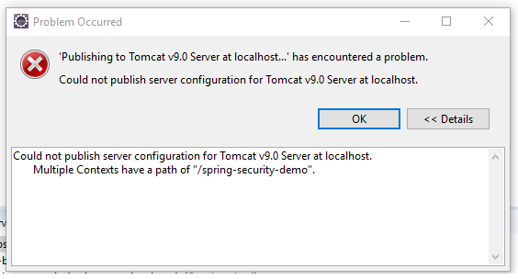

**The reason behands the problem**:

This said could mot publish server because we have multiple contexts at the same path.

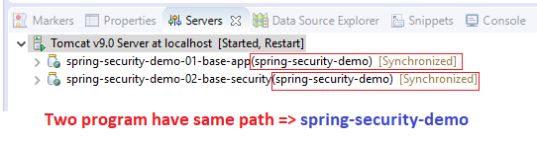

**Solution for the above problem**:

We can solve the problem by two ways.

* Delete the "Context Path" from Eclipse Tomcat Server (Quick Fix).
* Update project Property and given a unique name (best practice).
  + **Select project -> Properties -> Web Project Setting -> Change Context root -> Apply and Close.**

**Context Root**:

Basically, the context root is the root of our web application. Suppose we have a context root name "my-ecommerce-app" then we will access the project throw "[http://localhost:8080/ my-ecommerce-app](http://localhost:8080/%20my-ecommerce-app)"



48.1. Spring Security - Rename Context Roots